Protein Modeling Lab 1
- Draw trace residue
  - Will skip since this seems not as useful
    - Should look into how to draw these regardless
    - Easier way to get chains:
      - extract 7kkkA, 7kkk and chain A
      - Note that coloring the residues they asked for 711-1147 selects different (more) residues than trying to extract chain A through the extract function
- How many disulfides are there in the structure?
  - Each pair of cysteine counts as one
    - Just from counting it looks to be about 12?
    - Had to select the chain hide everything then show only disulfide bonds
    - Then getting each angle is as simple as ctrl clicking the beta carbon to sulfur to sulfur to the next beta carbon
      - Note that this became easier when I set the disulfide bond colors to be based on elements to differentiate between sulfur and carbons
    - For each disulfide in the range (chainA) report sulfur-sulfur dihedral angles defined by CB-SG-SG-CB
- 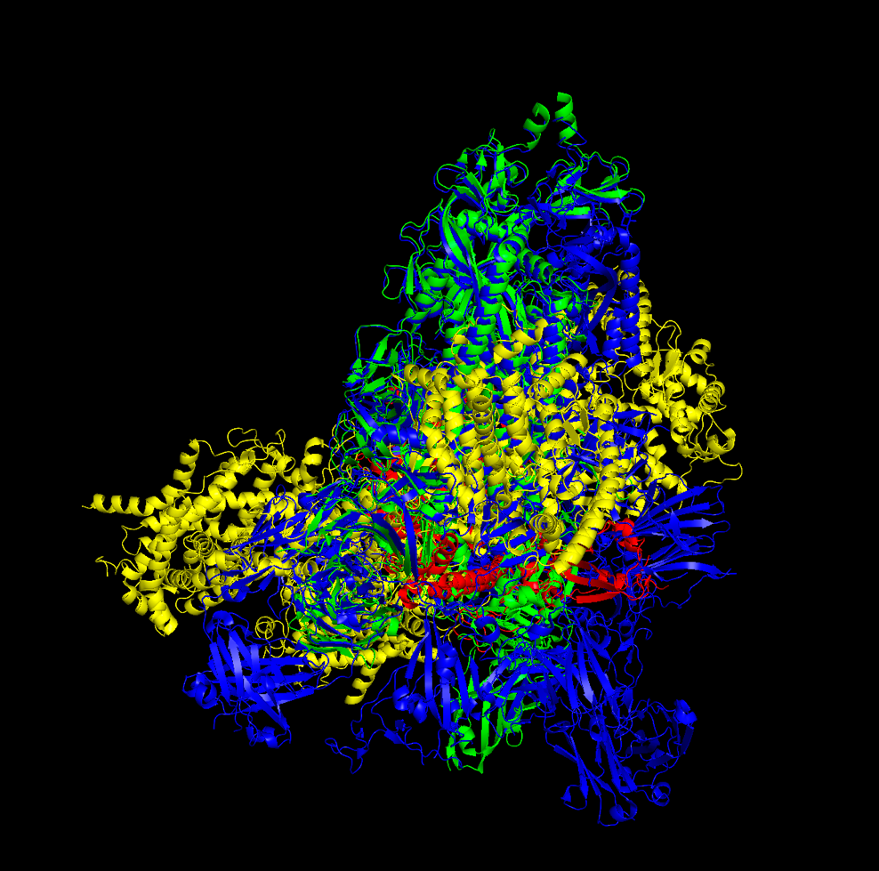
- Actually not sure how to describe the difference in neutralization mechanisms
  - Neutralizing antibody:
    - Proteins that help fight infection by blocking germs from getting into your cells
    - Most effective against viral infections
    - Non-neutralizing antibodies have different functions like labeling genes so that the immune system can detect them
  - Neutralizing nanobody:
    - Also known as VHH are single-domain antibody gragments originally found in llamas and other camelids
      - Unlike conventional IgG antibodies, which consist of covalently linked two light chains and two heavy chains
      - Nanobodies contain only monomeric target recognition module of the heavy chain while retaining similar specificity as IgG antibodies
      - Nanobodies are much smaller ~15kD, easier to produce and manipulate, offer robust thermostability, solubility, and permeability
  - Just visually it appears that 7kkk is much smaller idk that I can speak further about the mechanisms

Part2:
- I’m not sure I understood the question but overall:
  - Zinc fingers are a class of secondary structure that has the motifs needed to hold a zinc ion
  - I got one working with repeats of cystine and histidine amino acids:
    - CHCHCHCHCHCHCHC (replacing the x’s)

